DEFs recoloring program v.0.0.3 (author - Macron1)

1. Run program (RecolorDef.exe) (maybe installation of additional system libraries will be needed).

2. Form will appear:
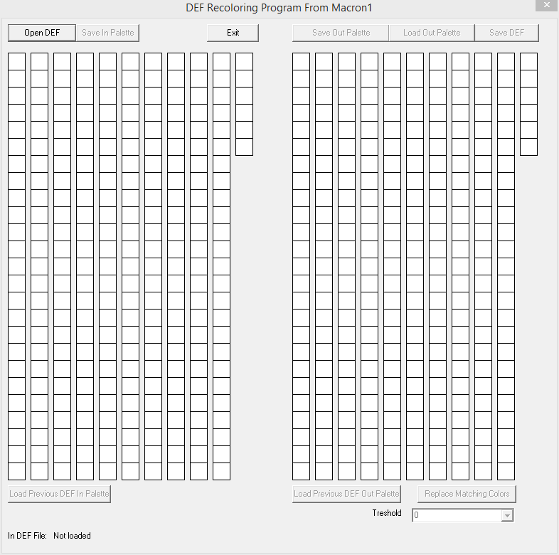

3. Press “Open DEF” and select file you want to recolor. Palette will be loaded from file:
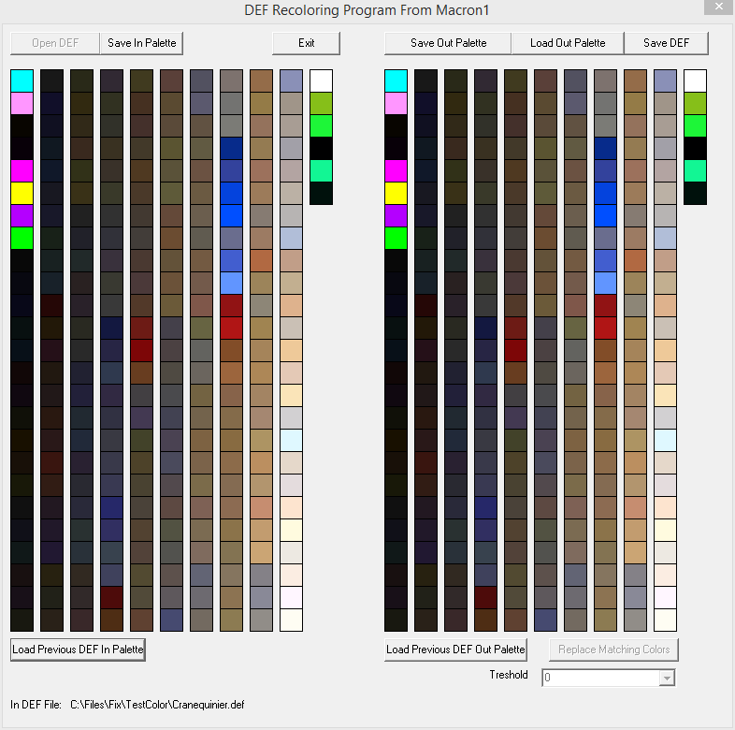

Right side – is the input palette. It is not editable.
Left side – is the output palette. To change color in your DEF press appropriate color and select new color:
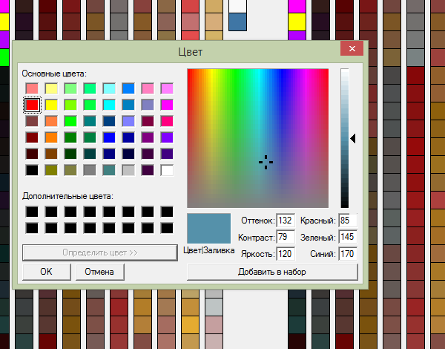

It will then appear on form:
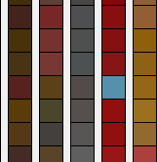

There is option on bottom of form:


If option “Don't take color from palette to color dialog” is not checked, then when clicked on palette color, palette color information will update Color Dialog color. If option is checked, Color Dialog will preserve information about previously used color.

What you can do with palette?

a) to save original palette press “Save In Palette” and input name of file to be saved to. Palettes have extension “.pal” and not compatible with any other programs.
b) to save output palette press “Save Out Palette”.
c) to load output palette from file press “Load Out Palette”.

This is helpful to save backup copies in progress – if something will go bad, you can always load palette from backup and redo job.

Note that first 8 colors (as I remember) are special colors. Change them only if you know, what you do. And I must have these 8 colors in other palette colors (they will mess with repetitions).

4. When you finished recoloring DEF, push “Save DEF” and input name of output file. Wow! You have recolored DEF:



5. Replacing colors automatically is also now possible.
For example, earlier you have made recolor of “Pikeman.def” to “Green Pikeman.def”. And you saved palette files “pikeman.pal” and “green pikeman.pal” (if you are not, then you run program, load “Pikeman.def” by “Open DEF”, and then save “pikeman.pal” by using “Save In Palette” button. Then you exit program. And do same thing to get “green pikeman.pal”).
You then run program, open “Cranequinier.def” and want to fasten things recoloring it to red color.
You press “Load Previous DEF In Palette” and show “pikeman.pal” to program.

Now button “Load Previous DEF Out Palette” is enabled. You press it and show program file “Red pikeman.def”:
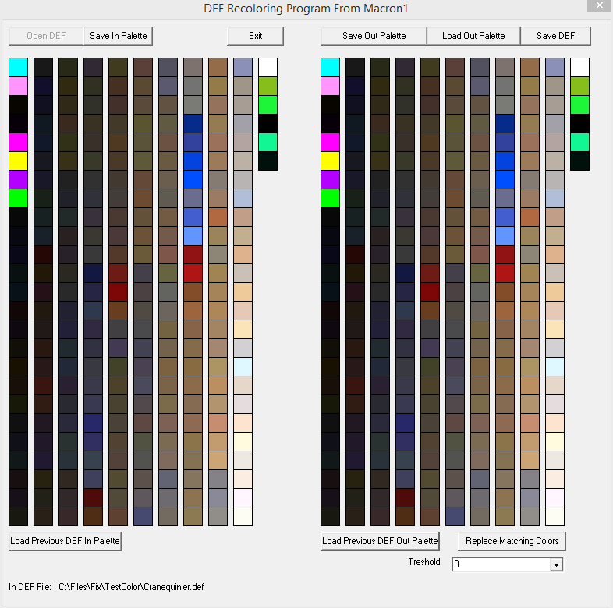

Now button “Replace Matching Colors” and “Treshold” control become enabled.
“Treshold” is initially set to “0” to allow most accurate color replacement.
Press “Replace Matching Colors”, and if previous DEF in palette contained colors your opened DEF contains, they will be recoloured automatically:
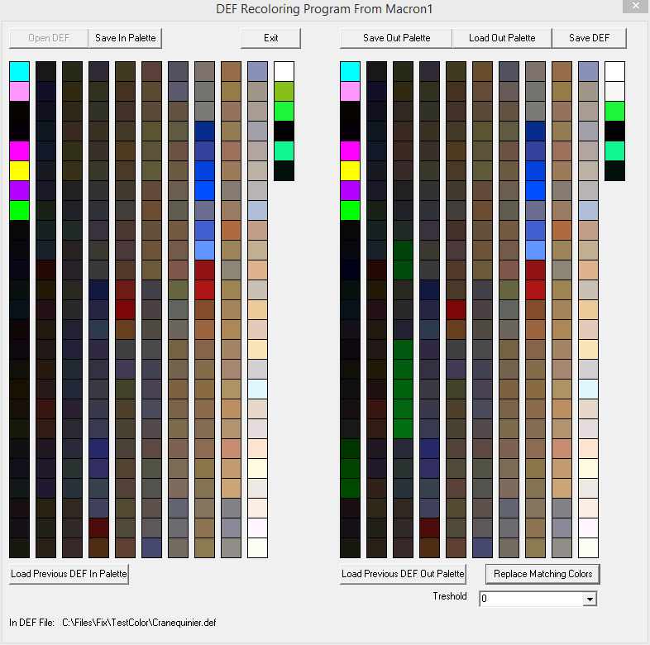

You then must recolor only colors left to correct.

If treshold is not 0, every color (and two nearest colors in palette) is compared to replacement colors by sqrt((RGB-RGB_{replace})²) and than replaced if sqrt<=treshold.

WARNING!

Current results of color replacement are heavely depend on DEF files used. If you have ideas, how to make good color replacement, your help will be appreciated.
For what this feature is thinked by me? For example, we have spritesheet with creature, where all frames are drawn in one palette, and 2-3 other palettes are represented by 1-4 frame.
Then we create DEF for full frames animation.
Then we create technical DEFs containing only 1-4 frames for different palettes (DEF for full frames palette consisting only of frames which have alternative coloring, and 2-3 other palettes coloring DEFs). Then we prepare palettes (“Save In Palette”) for all technical DEFs.

So in ideal program must compare colors and give on exit full frames animation DEFs, recolored on base of these.

PS I you wish to enhance program and add some functions (like DEF view – to see what you are doing), feel free to do it, but not forget to share corrected program and source files to VCMI community (vcmi.eu).

